DDL COMMANDS
Table Creation (CREATE): Write the SQL statements to create a database named
“employee” and the following tables based on the provided schema:
⦿ Departments
⦿ Location
⦿ Employees
SQL QUERY
- create database Employee;
- create table departments(department_id int primary key,department_name varchar(100));
- create table location(location_id int primary key,location varchar(30));
- create table employees(employee_id int primary key,employee_name varchar(50),gender enum('M','F'),age int,hire_date date,designation varchar(100), department_id int references departments(department_id),location_id int references location(location_id),salary decimal(10,2));
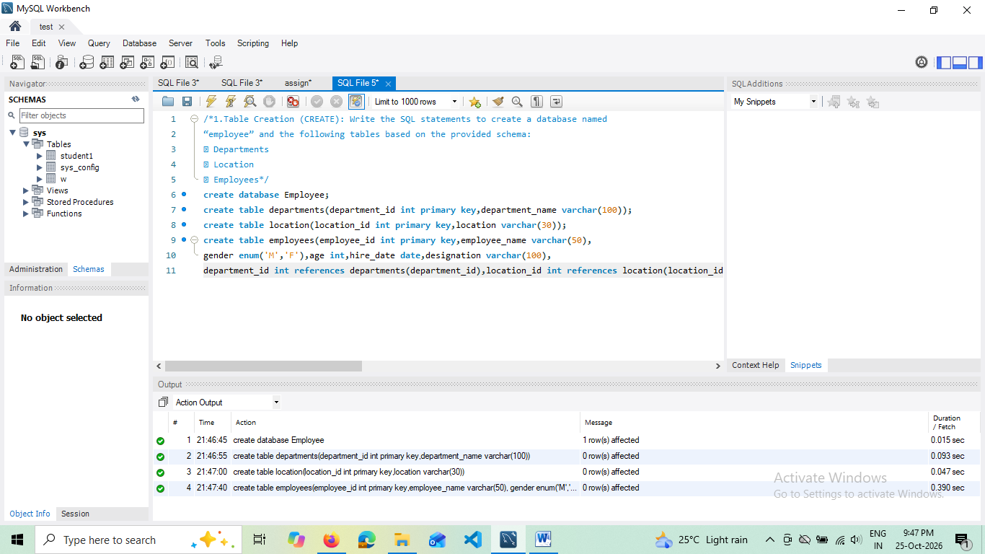

SQL QUERY
Value insertion
insert into Employee.departments values(101,'CS'),(102,'EC');
insert into employee.location values(2001,'KTM'),(2002,'TVM');
insert into employee.employees values(11,'ANNI','F',25,'2026-05-22','Teacher',101,2001,25000);

2) Table Alteration (ALTER): Consider the following scenarios and write the SQL
statements to alter the structure of the tables accordingly
- Add a new column named "email" to the Employees table to store
employee email addresses.

SQL QUERY

- alter table employees ADD column email varchar(25);
- Select * from employees;

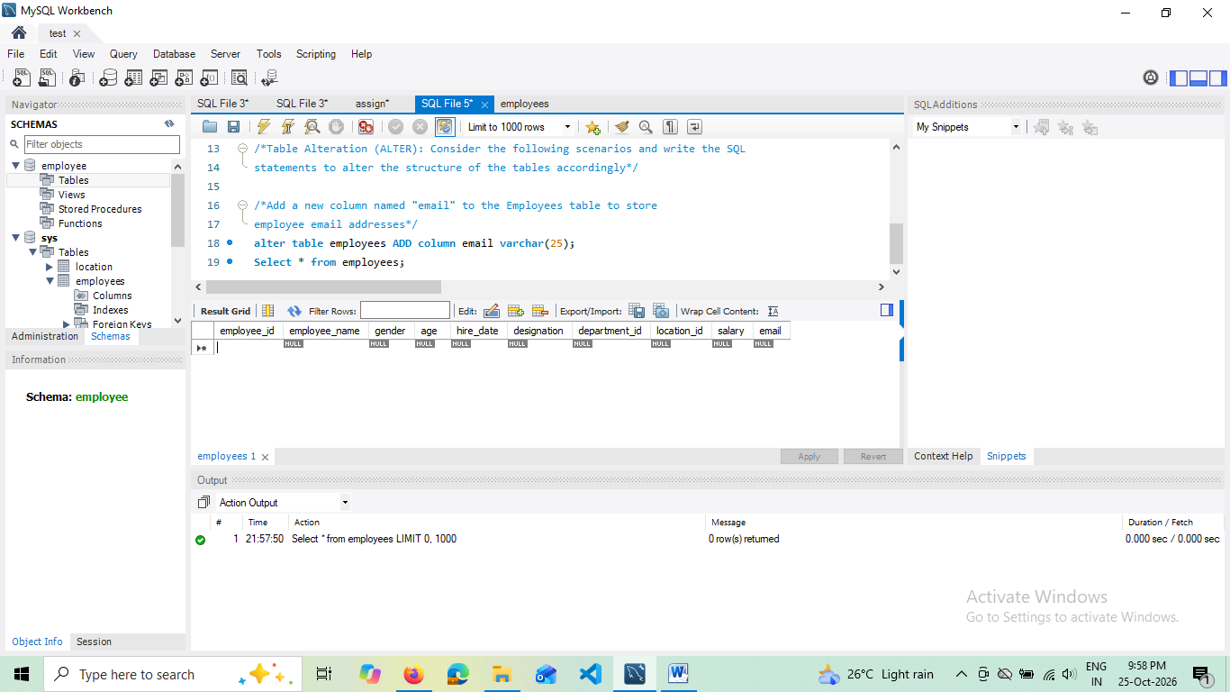
- Modify the data type of the "designation" column in the Employees
table to support a wider range of values.

- alter table employees modify designation varchar(255);
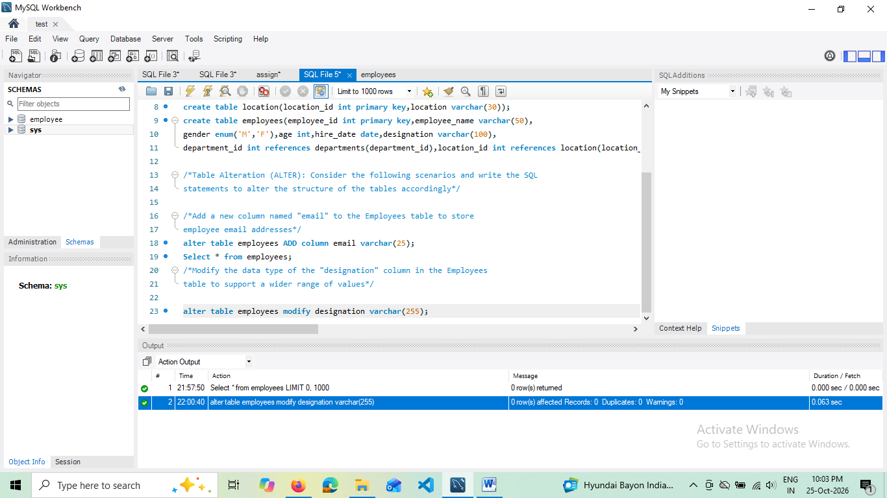

- Drop the “age” column from the Employees table.
- SQL QUERY

- alter table employee.employees drop age;
- select * from employee.employees;

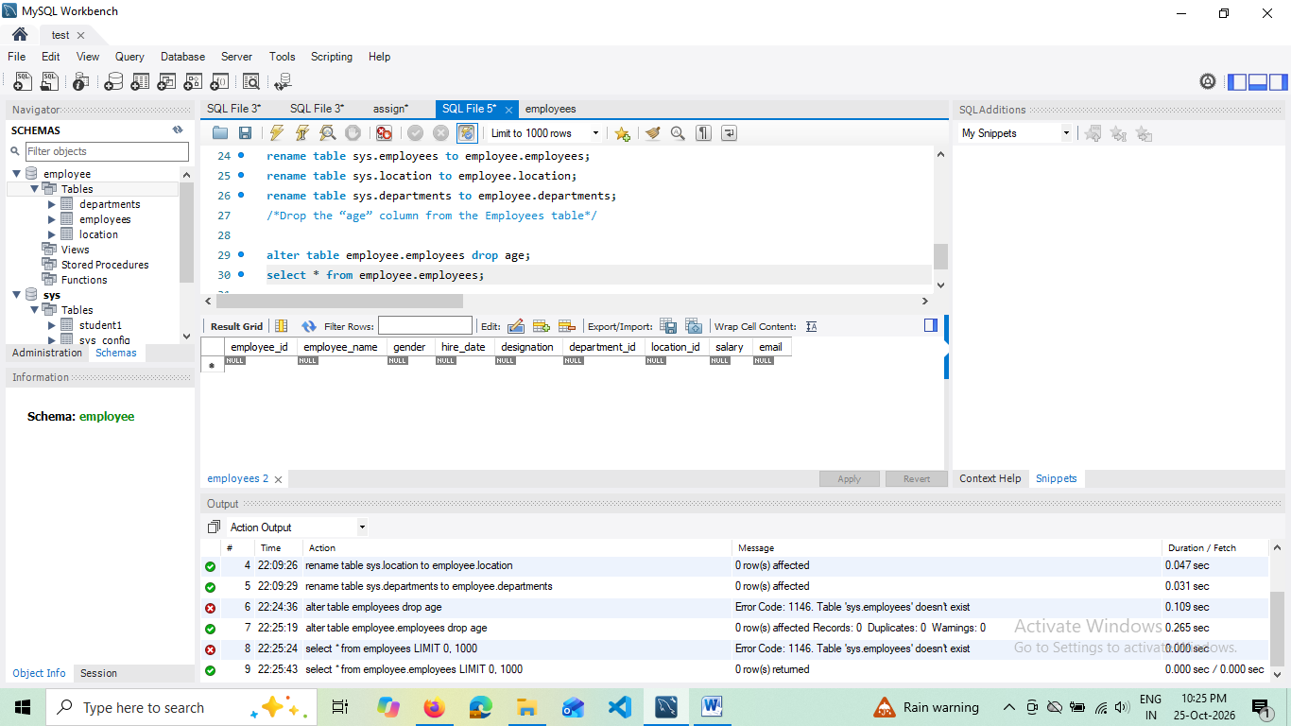

- Rename the “hire_date” column to “date_of_joining”.
- SQL QUERY

- alter table employee.employees rename column hire_date to date_of_joining;
- select * from employee.employees;
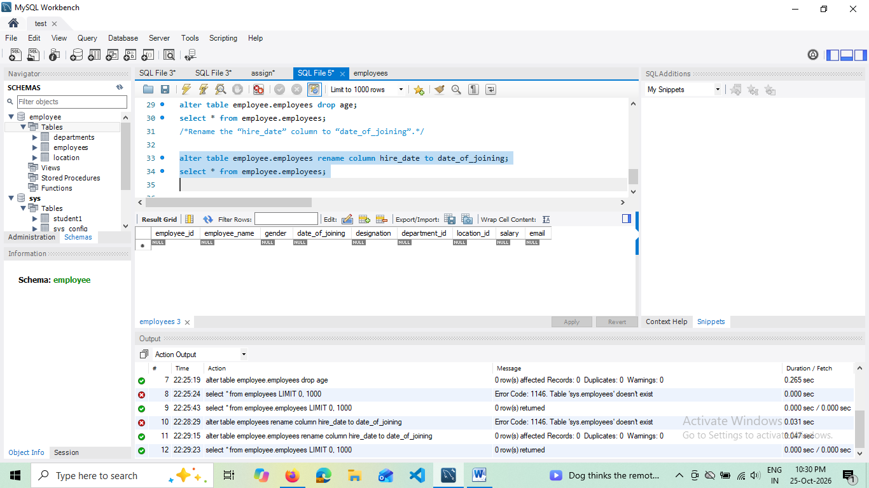

3)Table Renaming (RENAME): Rewrite the SQL statements to rename the
following tables:
⦿ Rename the "Departments" table to "Departments_Info"
SQL QUERY
- rename table employee.Departments to employee.Departments_info;
- select * from employee.Departments_info;

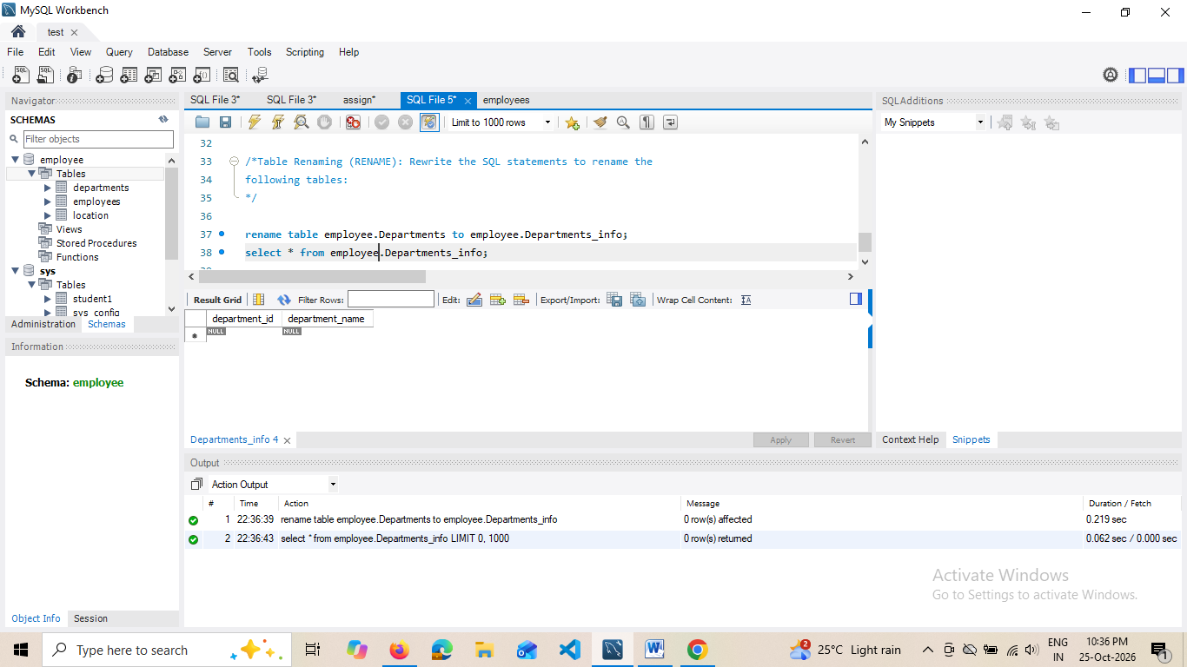

⦿ Rename the "Location" table to "Locations"
SQL QUERY

- rename table employee.Location to employee.Locations;
- select * from employee.Locations;

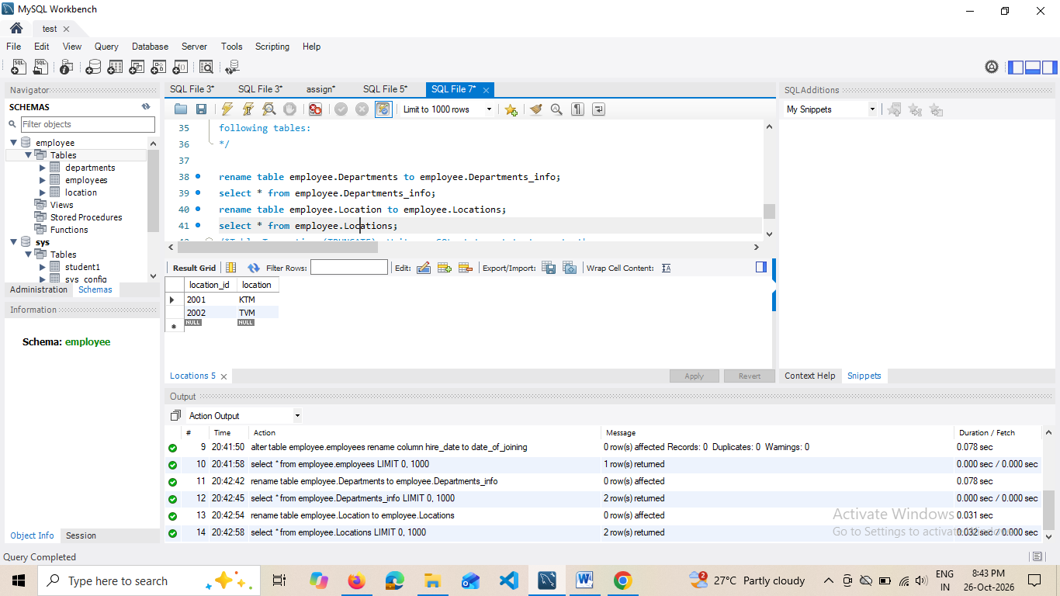

4)Table Truncation (TRUNCATE): Write an SQL statement to truncate the
Employees table.
SQL QUERY

truncate table employee.employees;
select * from employee.employees;

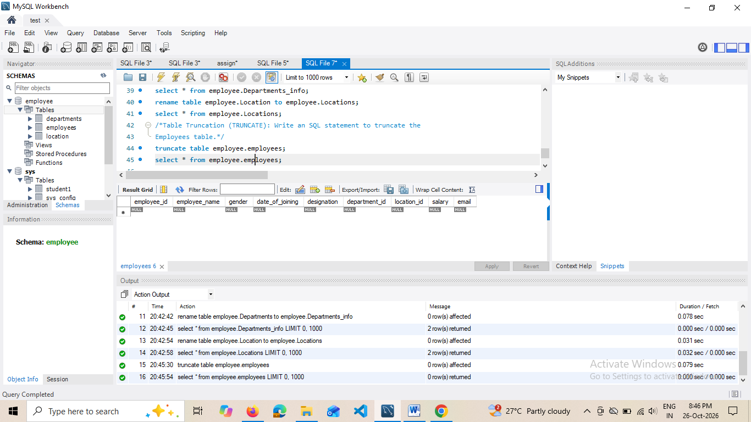
5)Database & Table Dropping (DROP): Write the SQL statements to drop the
Employees table and then the “employee” database.

DROP TABLE employee.employees;
DROP DATABASE employee;
select * from employee.employees;

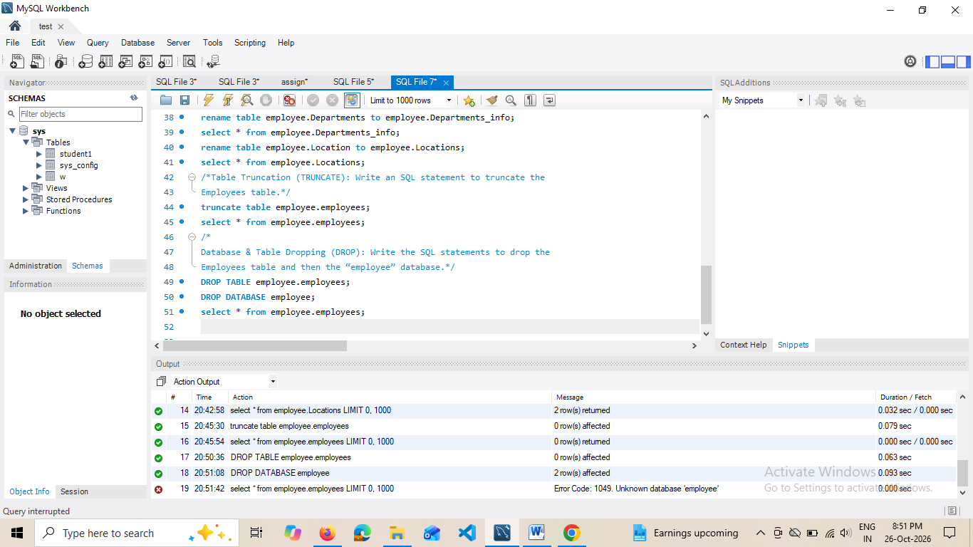

Constraints::
1. Database Recreation:
⦿ Drop the 'employee' database if it exists and recreate it using the
provided schema, ensuring that all tables are created with the
appropriate constraints as instructed.

- DROP DATABASE IF EXISTS employee;
- USE employee

2) Departments Table
- Ensure that the "department_id" uniquely identifies each department.
Department table Already Created by using primary key
PRIMARY KEY, -- Uniquely identifies each department (not null + unique)
- Set up constraints on the "department_name" to avoid duplicate and null
entries
So we use Alter Command to Add Other Constraints
ALTER TABLE Employee.departments
MODIFY COLUMN department_name VARCHAR(100) NOT NULL;
-- 2. Prevent duplicate entries
ALTER TABLE Employee.departments
ADD UNIQUE (department_name);
---Check is it works?
INSERT INTO employee.departments (department_id, department_name)
VALUES (101, 'Computer Science');
INSERT INTO employee.departments (department_id, department_name)
VALUES (101,'CS');
INSERT INTO employee.departments (department_id, department_name)
VALUES (102,'Computer Science');

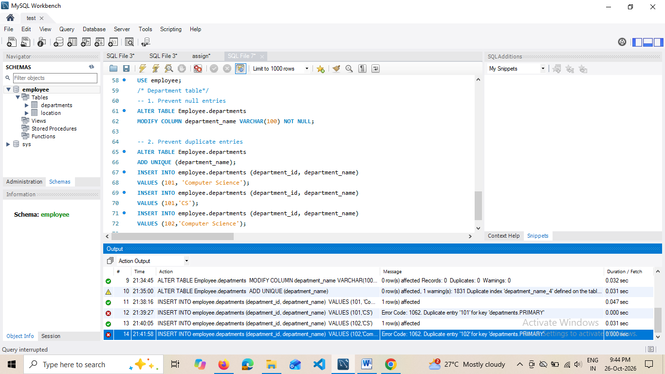

3) Location Table:
⦿ Establish a mechanism to automatically generate unique identifiers for
each location, ensuring that they are incremented sequentially.
⦿ Implement constraints to prevent the insertion of null and duplicate

- Ensure location_id is AUTO_INCREMENT and a Primary Key

ALTER TABLE employee.location
MODIFY COLUMN location_id INT AUTO_INCREMENT;

- Prevent null entries for the location name
ALTER TABLE employee.location
MODIFY COLUMN location VARCHAR(100) NOT NULL;

- Prevent duplicate entries for the location name
ALTER TABLE employee.location
ADD UNIQUE (location);

Check:
INSERT INTO employee.location (location)
VALUES ('KTM');
select * from location;
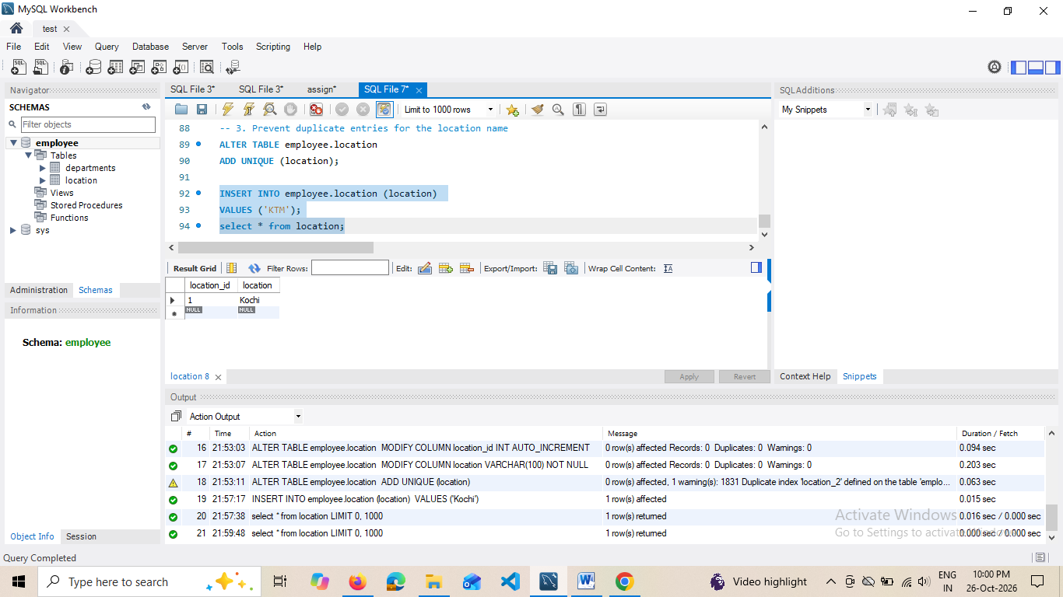
- unique contraint check
- INSERT INTO employee.location (location)
VALUES ('Kochi');
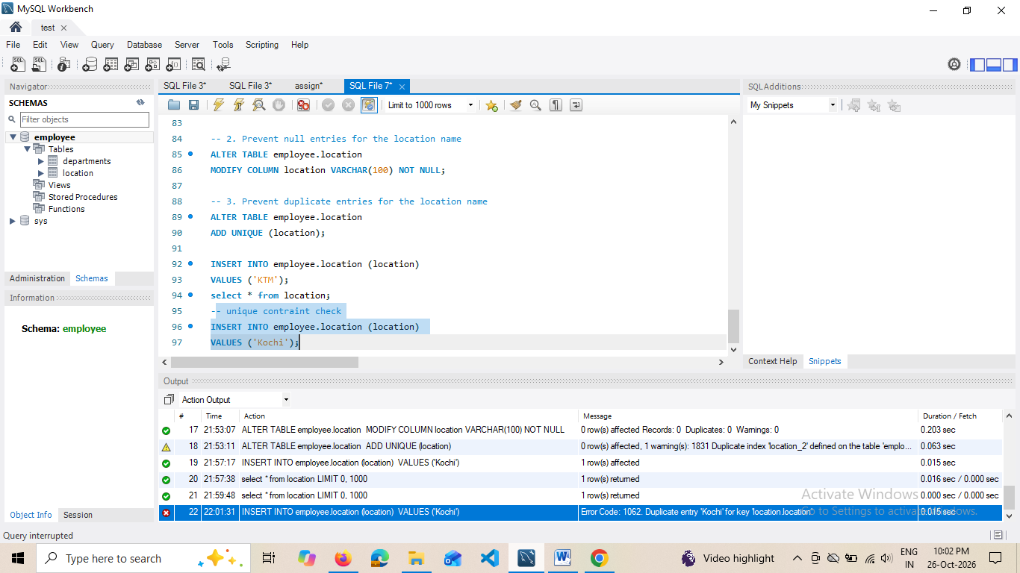

Employee Table
create table employees(employee_id int primary key,employee_name varchar(50) not null,gender enum('M','F'),age int check(age>=18),hire_date date default(current_date),designation varchar(100),department_id int references departments(department_id),location_id int references location(location_id),salary decimal(10,2));

1. Distinct Identifier for Each Employee
- Code: employee_id INT PRIMARY KEY
- How it works: Setting employee_id as the Primary Key ensures two things: every ID must be completely unique (no duplicates allowed),
2. Create a restriction to ensure that the employee's name is always
provided.
- employee_name varchar(50) not null
3. Limit the acceptable values for the "gender" field to only 'M' or 'F'.
- gender ENUM('M', 'F')
The ENUM data type restricts the column's allowed values to only the predefined list
4. Enforce a condition to ensure that the employee's age is 18 or above
- age INT CHECK (age >= 18)
The CHECK constraint acts as a rule-checker. It evaluates the expression age >= 18 on every insert or update,
5. Automatically assign the current date to the "hire_date" field if not
Specified
- hire_date DATE DEFAULT (CURRENT_DATE)
6. Establish links between the "department_id" and "location_id" fields in
the "employees" table and their respective tables.
- department_id int references departments(department_id),location_id int references location(location_id)
- default date
- INSERT INTO employee.employees (employee_id, employee_name, gender, age, designation, department_id, location_id, salary)
VALUES (1, 'Rahul', 'M', 25, 'Developer', 101, 2001, 45000.00);
- select * from employees;
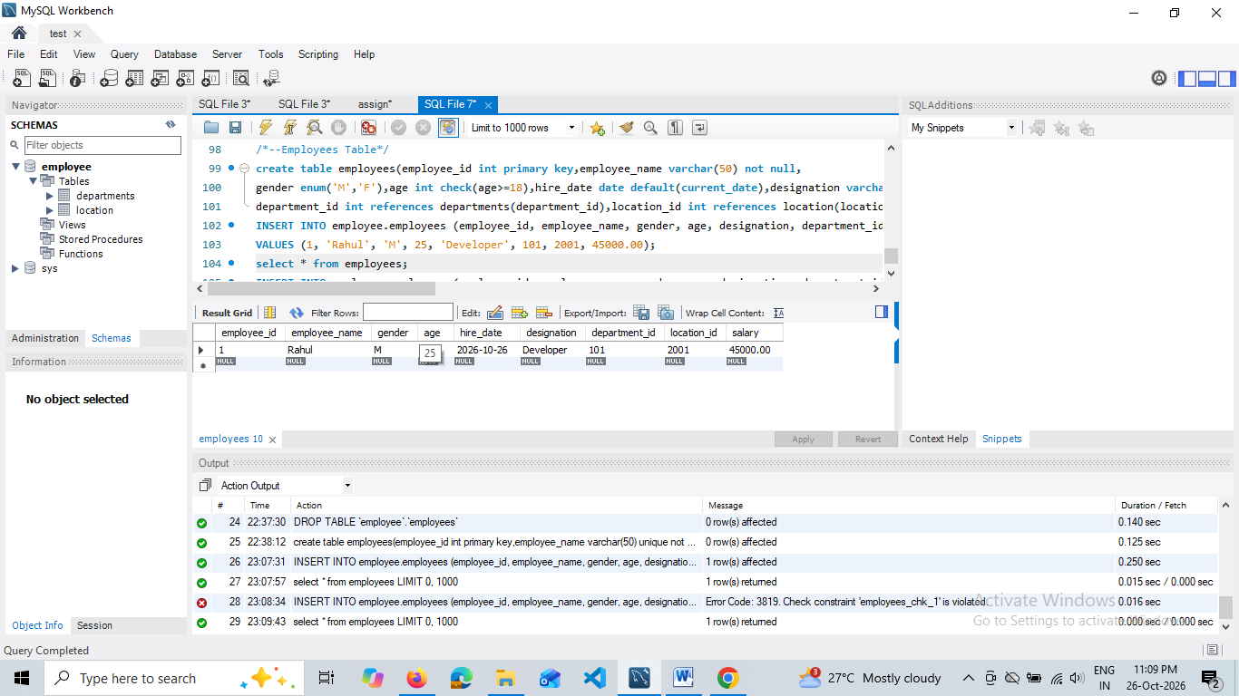

Check constraint
INSERT INTO employee.employees (employee_id, employee_name, gender, age, designation, department_id, location_id, salary)
VALUES (4, 'Arun', 'M', 17, 'Intern', 101, 2001, 20000.00);
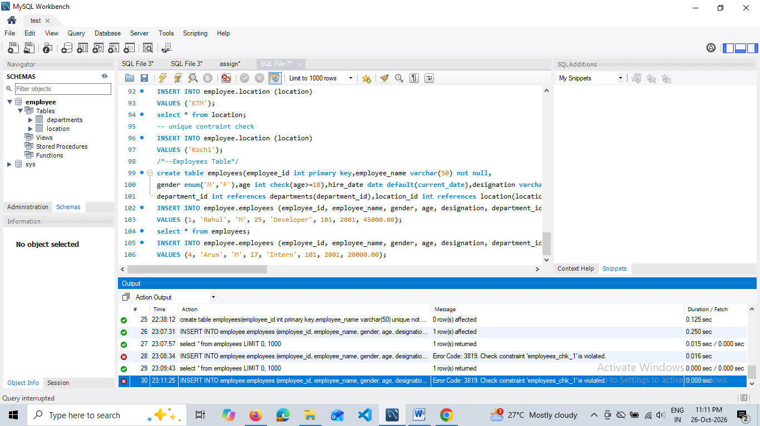

Limit the acceptable values for the "gender" field to only 'M' or 'F'.
INSERT INTO employee.employees (employee_id, employee_name, gender, age, designation, department_id, location_id, salary)
VALUES (3, 'Priya', 'X', 26, 'HR', 101, 2001, 38000.00);
